**SPRINT 3**

|  |  |
| --- | --- |
| Team ID | PNT2022TMID17878 |
| Project Name | Exploratory Analysis Of Rainfall Data In India For Agriculture |

**TO PREPARE THE WEBSITE PAGES TO PREDICT THE RAINFALL RATE AND THE RECOMMENDED CROP TO GROW**

**Index.html**

<!DOCTYPE html>

<html lang="en">

<head>

<meta charset="UTF-8">

<link rel="stylesheet" href="https://stackpath.bootstrapcdn.com/bootstrap/4.3.1/css/bootstrap.min.css" integrity="sha384-ggOyR0iXCbMQv3Xipma34MD+dH/1fQ784/j6cY/iJTQUOhcWr7x9JvoRxT2MZw1T" crossorigin="anonymous">

<title>Rainfall-Prediction</title>

</head>

<style>

body{

background-image: url('https://i.gifer.com/A4XX.gif') ;

background-repeat: no-repeat;

background-attachment: fixed;

background-size: cover;

}

</style>

<body>

<br><br><br><br>

<div class="container">

<h1 class="text-center m-3 badge-dark text-wrap">

Rainfall Prediction for India

</h1>

<div class="card container" style="width: 65%; ">

<div class="card-body">

<form action="/" method="post">

<div class="form-group">

<label for="formGroupExampleInput1">MONTH</label>

<input

type="text"

class="form-control"

id="formGroupExampleInput1"

name="Month"

required

/>

</div>

<div class="form-group">

<label for="formGroupExampleInput2">STATE</label>

<input

type="text"

class="form-control"

id="formGroupExampleInput2"

name="state"

required

/>

</div>

<center><button type="submit" class="btn btn-dark">CHECK</button></center>

</form>

</div>

</div>

</div>

</body>

</html>

**OUTPUT:**

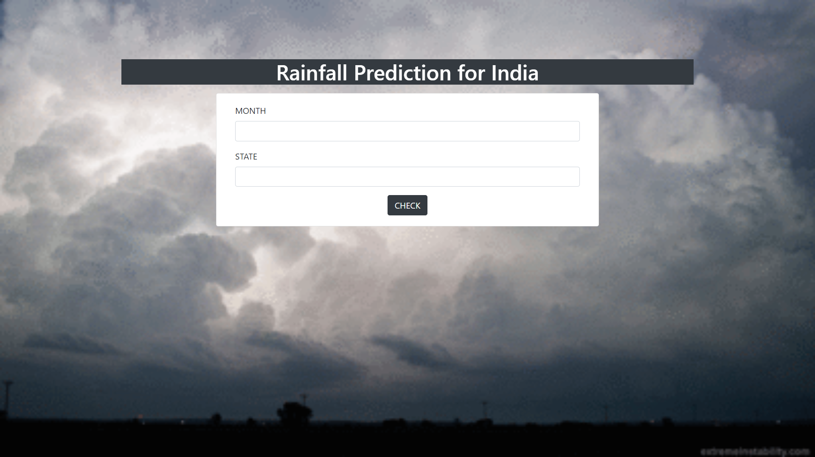

**result.html**

<!DOCTYPE html>

<html lang="en">

<head>

<meta charset="UTF-8">

<link rel="stylesheet" href="https://stackpath.bootstrapcdn.com/bootstrap/4.3.1/css/bootstrap.min.css" integrity="sha384-ggOyR0iXCbMQv3Xipma34MD+dH/1fQ784/j6cY/iJTQUOhcWr7x9JvoRxT2MZw1T" crossorigin="anonymous">

<title>Rainfall-Prediction</title>

</head>

<style>

body{

background-image: url('https://i.gifer.com/A4XX.gif') ;

background-repeat: no-repeat;

background-attachment: fixed;

background-size: cover;

}

</style>

<body >

<br><br><br><br>

<div class="container" >

<h1 class="text-center m-3 badge-dark text-wrap">Rainfall Prediction</h1>

<div class="card container" style="width: 50%;">

<div class="card-body" >

<form action="/" method="post">

<div class="form-group">

<label for="formGroupExampleInput1">Month</label>

<input

type="text"

class="form-control"

id="formGroupExampleInput1"

name="Month"

placeholder="{{Month}}"

required

/>

</div>

<div class="form-group">

<label for="formGroupExampleInput2">state</label>

<input

type="text"

class="form-control"

id="formGroupExampleInput2"

name="Year"

placeholder="{{state}}"

required

/>

</div>

<h2 class="text-center text-wrap" >The Rainfall rate is {{res}} mm </h2>

<h2 class="text-center text-wrap">Can plant {{ans}} for good yield</h2>

</form>

</div>

<center><a href="/"><button type="submit" class="btn btn-dark">Back</button></a></center>

</div>

</div>

</body>

</html>

**OUTPUT:**

